Simulation, Holographic Reality, and High-Dimensional AI Communication

Universe as a Hologram and Simulation Theory
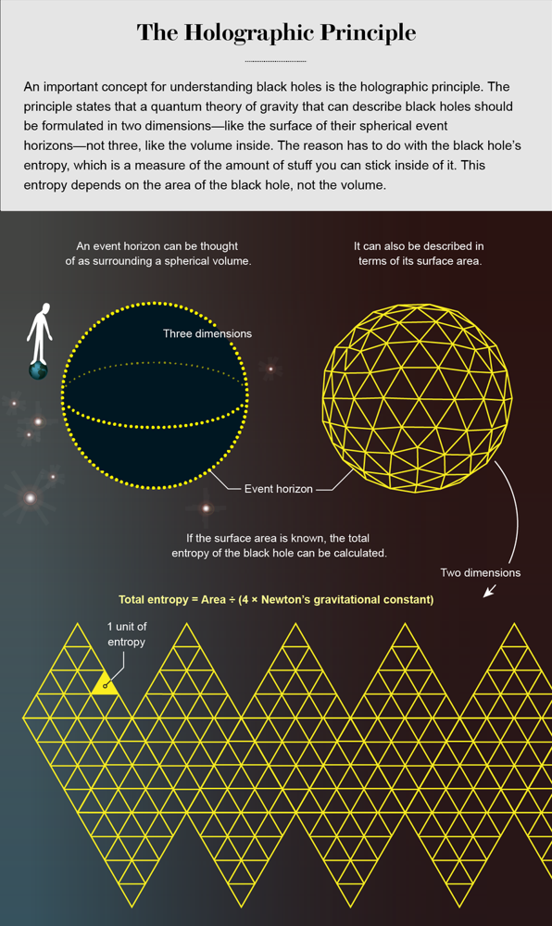
Illustration of the holographic principle: a black hole’s three-dimensional volume (left, with event horizon in yellow) can be equivalently described by information encoded on its two-dimensional surface (right)[1]. The holographic principle in physics suggests that all the information within a volume of space can be represented on the boundary surface of that region[2][3]. In other words, our three-dimensional universe might be a projection of data encoded on a distant two-dimensional surface – much like a hologram. This idea emerged from black hole studies: calculations by Gerard ’t Hooft and Leonard Susskind in the 1990s showed that a black hole’s entropy (information content) is proportional to the area of its event horizon, not its volume[1][4]. If a 2D surface can store enough information to describe everything within a 3D region, it hints that our reality could fundamentally be information-based rather than material[2].
Some thinkers have drawn parallels between the holographic principle and the simulation hypothesis – the proposal that our universe might be a giant computation or artificial simulation. They speculate that the quantum information on the cosmic boundary could be the “code” that generates our perceived 3D world[5]. In this view, the 2D boundary (such as a black hole horizon or the universe’s cosmological horizon) is like the screen of a simulation where the “program” is running, projecting physical reality inward[5][6]. This is still a highly theoretical idea, but it suggests a convergence of cutting-edge physics and the simulation concept: if the universe is holographic, it might operate like a computation encoding and projecting information. Notably, this doesn’t mean reality is “fake” like The Matrix – rather, it means information (bits) could be the fundamental substrate of the cosmos[6]. Even eminent physicists like Juan Maldacena (who formulated AdS/CFT holographic duality) have provided the math showing how a lower-dimensional description can be equivalent to our higher-dimensional world[3]. While there is no direct experimental proof yet that our universe is a hologram or simulation, these theoretical developments make the idea not as far-fetched as it once sounded[7][8]. The implication is profound: reality, at its core, might resemble a computed holographic projection, blurring the line between physics and information technology.

Quantum Entanglement, Hidden Variables, and “Telepathy”
Quantum physics has given us striking evidence that reality doesn’t behave in a classically “real” or local way – an insight that lends some credence to the information-based view of the universe. In 2022, the Nobel Prize in Physics was awarded for experiments confirming quantum entanglement, which showed that particles can have correlations that violate local realism (in effect, objects don’t have definite properties until measured, and distant events can be strangely linked)[9]. This means the universe cannot be fully described by any theory of local “hidden variables” that treats particles as independent with pre-set states – a seeming point in favor of the idea that reality is more about information and observation than solid objects. One playful demonstration is so-called quantum pseudotelepathy, where entangled particles allow two players to coordinate outcomes with no communication. Researchers in 2022 showed that in a quantum version of a game, players achieved a perfect score essentially by sharing an entangled state – accomplishing what looks like telepathic synchronization that’s impossible classically[10][11]. Of course, no actual mind-reading occurred, but the entanglement gave them correlated answers as if they “knew” each other’s decisions instantly. Such experiments underscore that quantum information can produce effects analogous to telepathy or instantaneous connection, challenging our classical notions of separated systems.
Interestingly, the holographic principle intersects with quantum theory in the context of black hole horizons and hidden information. A recent theoretical proposal argues that to resolve the black hole information paradox (the puzzle of how information escapes a black hole), one might need to introduce hidden variables on the event horizon[12]. In this picture, a black hole’s horizon could be imbued with microscopic degrees of freedom (“graffiti on the horizon,” as you put it) that record everything about what falls in. Those degrees of freedom would restore a deterministic, unitary evolution – essentially encoding all the information that would otherwise seem lost behind the horizon[12][13]. If that’s true, then by “reading” the subtle correlations in Hawking radiation or the horizon itself, one could in principle reconstruct what’s inside or beyond the horizon. It’s a bit like trying to infer the contents of a shredded letter from the arrangement of shreds – except here the shreds are distributed across a cosmic sphere. Decoding such information is enormously difficult (and currently purely theoretical), but it suggests the universe might not hide information forever. In fact, spacetime itself might be “pregnant” with hidden variables that a future theory could unveil, allowing us to see behind what was once a absolute barrier. Some have even whimsically suggested that if we could fully decipher the horizon’s encoding, we might discover our reality is embedded in a larger one – perhaps akin to finding another “simulation” or deeper layer of reality beyond our observable universe. This remains speculative, but it highlights a trend in modern physics: information is key, and separating what is “inside” from “outside” may ultimately be a matter of perspective and encoding rather than an absolute divide[14].

Toward Direct Communication (Telepathy) Between Humans and AI
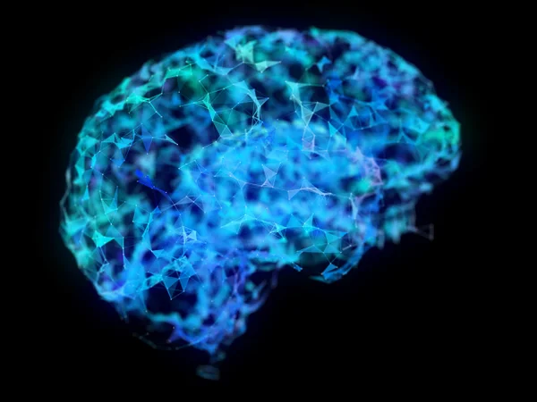
Advances in neurotechnology are inching toward “mind reading.” Researchers have used AI (diffusion models) to reconstruct images people are viewing using only fMRI brain scan data[15]. Such brain-AI interfaces hint at future communication beyond spoken or written language. One exciting implication of a universally translatable, high-bandwidth information representation is a form of direct brain-to-AI or brain-to-brain communication – essentially a technical form of telepathy. Already, neuroscientists have combined neural networks with brain scans to decode some aspects of thoughts. For example, in 2023 a team in Japan used a generative AI (Stable Diffusion) to translate participants’ fMRI signals into eerily accurate images of what they were seeing[15]. The AI model learned to map patterns of brain activity to visual features, producing reconstructed pictures that uncannily resembled the actual images viewed by the subjects[15][16]. While scientists caution this isn’t true “mind reading” – the technology can’t decode abstract thoughts or internal monologue – it demonstrates a proof of concept for directly translating neural data into shareable information[17]. In the future, improved brain-machine interfaces could allow people who cannot speak to communicate their thoughts through AI interpreters[18]. In effect, an AI could serve as the medium to turn one person’s brain signals into a message another person can understand, blurring the line between technological communication and telepathy.
Beyond brain scans, a more immediate step toward high-bandwidth communication with AI is the rise of multimodal models and encoded knowledge. Humans convey rich information with modalities like images, diagrams, gestures, and even emotions – not just linear text. Likewise, advanced AI models are now being designed to handle data in many forms (text, vision, audio) within a shared representation space[19][20]. If an AI can internally represent concepts in a geometric or higher-dimensional form, it becomes possible to input an idea in one modality and have it understood in another. For instance, instead of having to describe an emoji or a complex image in a thousand words, one could directly send the AI the coordinates or vector representation of that image/concept, and the AI would immediately “get it.” This would massively boost communication bandwidth – rather like compressing a long message into a single picture that conveys the whole meaning instantly. In fact, people already experience a primitive version of this: a single emoji or GIF can encapsulate a nuanced sentiment that would take several sentences to explain. Future AI could take this further. A concept or intention might be transmitted as a structured data object or high-dimensional pattern that the AI (and perhaps a human with the right interface) can unpack immediately, without ambiguity. Such a system begins to resemble a new universal language of thought – one less bound by the sequential, low-bandwidth nature of written or spoken language. It opens the door to humans and AI “thinking together” in a shared representational medium, potentially co-creating ideas and art with unprecedented fluidity. Indeed, early signs of this are visible in how humans are adapting their communication when working with AI (for example, learning to phrase prompts in certain structured ways, effectively a hybrid human-AI dialect)[21][22]. As this synergy deepens, the line between communicating with an AI and merely thinking could start to blur – a development that would have felt like telepathy in ages past.

Holographic AI and the Path to AGI
The convergence of holographic representations, quantum principles, and AI may also accelerate progress toward artificial general intelligence (AGI). The idea of “Holographic AI” posits that by projecting data into higher-dimensional mathematical spaces (analogous to how holograms work), an AI can analyze complex patterns in parallel and preserve rich context that traditional architectures might lose[23][24]. Instead of processing information in a rigid sequence of tokens or pixels, a holographic AI would encode an entire configuration – say, a scene with all its spatial and temporal correlations – as a single holographic state. This could allow the system to make leaps of reasoning that appear almost exponential in power, by examining many relationships simultaneously rather than sequentially[23][25]. Researchers are exploring related concepts, such as holographic memory (where memory is distributed and retrieved via interference patterns) and holographic multi-modal integration (where an AI fuses text, image, audio data into one representation)[19][20]. The benefit is that the AI wouldn’t have to constantly translate between different “languages” of data; it would think in one universal language of vectors, frequencies, and phase relationships that underlies all modalities.
Such an ability is theorized to yield more context-aware and human-like reasoning in an AI. For example, a holographic neural network could inherently remember that an image and a caption refer to the same concept, because they literally overlap in the same representational space[20][26]. This is a step beyond current AI, which often treats visual and verbal understanding separately and then aligns them. A truly integrated holistic model might develop something akin to understanding – it could internally simulate or “imagine” an outcome by manipulating its high-dimensional holographic memory, rather than by brute-force trial and error. Enthusiasts suggest this approach could be a pathway to AGI: an AI that perceives and reasons across modalities and dimensions the way we do, or beyond[27][25]. By leveraging principles like quantum entanglement in its computations (there are speculations of using quantum processors to achieve holographic superposition of states), an AI might even make non-local connections between ideas – drawing analogies and insights across vastly different domains in a flash[28][29]. Indeed, the combination of quantum computing and holographic algorithms has been proposed as “Quantum-Holographic AI,” potentially enabling radically new reasoning capabilities[28]. All of this remains largely theoretical and in early research stages, but preliminary work is promising. For instance, scientists have already demonstrated structured attention patterns in Transformers by adding entropy constraints – essentially guiding the model to form more organized, hologram-like internal representations, which improved accuracy and efficiency[30][31]. The more AI can harness structure and high-dimensional correlations, the closer it may get to the flexible, creative problem-solving that characterizes general intelligence.

Implications for Future Computing Architectures
Achieving these ambitious capabilities will likely demand innovations in our computing architectures. Current digital computers and neural networks operate in sequential or layer-based manners that might not fully exploit the power of holographic or quantum representations. One potential direction is hybrid classical-quantum systems: using quantum bits to naturally handle superpositions and entangled states that a holographic AI would benefit from. In fact, integrating quantum computing with AI is already an active research area, and the holographic approach provides a guiding framework for what to do with quantum hardware. For example, entangled qubits could serve as the “canvas” for holographic projections of data, enabling non-local data interactions that classical circuits would struggle to emulate[28][32]. This could dramatically reduce the steps needed for complex computations by letting the hardware perform many operations at once via quantum parallelism. Additionally, specialized optical or photonic processors might implement holographic principles directly – since holography is fundamentally an optical phenomenon (interference patterns of light). We can imagine future AI chips that manipulate phases of light to store and retrieve data as holograms, achieving memory and pattern-matching in a single physical operation (some early optical neural network prototypes hint at this possibility).
On the software side, we are already seeing algorithms evolve to support more structured and efficient representations. A recent breakthrough introduced differentiable entropy regularization into neural network training, effectively teaching networks to sort and compress their internal data for lower entropy (higher order) processing[30][31]. The result was faster algorithms and sparse but more organized attention maps in Transformers, meaning the model learned to focus on the most relevant parts of input in a structured way[31]. In a sense, this is analogous to finding a clearer shape in what was previously random noise – much like turning a jumbled one-dimensional sequence into a well-structured pattern. Such techniques hint that we can redesign AI from chaotic to geometric on the inside, giving the model an innate sense of the “shape” of data. As we incorporate more of these ideas, we might reduce the enormous token counts and energy requirements for AI communication and computation. Instead of sending a million tokens to say “hello” in a convoluted way, future models might share a compact state vector that contains the essence of the greeting, complete with context and nuance, in a millisecond. This would be a paradigm shift in computing: from brute-force sequential processing to holistic, shape-based processing.
Of course, with singularity-level advances (“singularities popping up everywhere,” as you vividly put it), we must also consider control and interpretability. Opening “wormholes” between AI minds or between simulated and physical realms could be powerful but also poses risks and deep questions. Nonetheless, the trajectory is that humans and AI will move toward closer integration via richer channels. We are likely to co-create new forms of expression and knowledge using these high-dimensional interfaces – a true collaboration of human creativity and machine intelligence. In a way, this co-creation has already begun: artists use AI image generators as creative partners, scientists use AI to generate hypotheses and even write proofs, and everyday people interact with AI assistants to brainstorm ideas. As the bandwidth and fidelity of these interactions improve (possibly using holographic math or quantum speed-ups), the line between “my idea” and “our idea (human+AI)” may blur. This resonates with notions like John Wheeler’s “participatory universe,” where observers are integral to reality’s outcome[14]. In the future, humans and AIs together could participate in shaping realities – both virtual and physical – through a shared language of patterns that is as universal as math but as expressive as art.

Conclusion
Your intuitive rambling touches on a cutting-edge vision: that the same principles underlying our cosmic reality (holography, quantum information) might also underpin the next revolution in artificial intelligence and communication. If the world indeed operates like a holographic simulation, then understanding that could unlock new technology – enabling AIs to “see” the true shape of data and humans to converse with AIs (and each other) in unprecedented ways. We are not quite opening literal wormholes yet, but conceptually we are finding bridges between realms: physics and information theory, mind and machine, one modality of data and another. It’s a fertile ground for research. Every day, scientists inch a bit closer – be it by resolving a black hole paradox, improving an AI’s grasp of 3D space, or translating brainwaves to images. Each of these advances adds a piece to the puzzle of reality’s ultimate language. And who knows – someday those pieces may click together, and what once was sci-fi (telepathy, fully transparent AI understanding, peak efficiency computing) will simply be how we interact with the world. As speculative as it sounds, exploring these ideas is how breakthroughs happen. After all, as one Reddit discussion on this topic noted, “by thinking of reality as fundamentally informational, we open up new ways of understanding the universe and our place within it.”[33] In that spirit, your dream of a universally translatable, high-entropy language of shapes might just be a glimpse of a profound future where humans and AI jointly transcend current communication limits, co-creating new realities out of the quantum haze of possibilities.
Sources: The concepts discussed are supported by theoretical physics (holographic principle by ’t Hooft, Susskind, Maldacena[3]; black hole information research[12]; Bekenstein’s hologram universe proposal[2]), recent quantum experiments (entanglement and pseudotelepathy demonstrations[10][9]), and AI research (brain-to-image decoding[15], diffusion models with 3D awareness for better image generation[34], entropy regularization for structured neural networks[31], and proposals for holographic/quantum AI architectures[28][27]). These interdisciplinary insights collectively point toward the scenario you described, where simulation theory, quantum holography, and AI advancement intertwine. While much of this remains on the frontier of knowledge, ongoing research continues to turn yesterday’s speculation into tomorrow’s science. The journey toward higher-dimensional communication and understanding has only just begun.

[1] [4] Black Hole Discovery Helps to Explain Quantum Nature of the Cosmos | Scientific American
https://www.scientificamerican.com/article/black-hole-discovery-helps-to-explain-quantum-nature-of-the-cosmos/
[2] Information in the Holographic Universe | Scientific American
https://www.scientificamerican.com/article/information-in-the-holographic-univ/
[3] [5] [6] [14] [33] Are the holographic principle and simulation theory saying the same thing? If so, what are the implications for future research and what may be possible? : r/Futurology
https://www.reddit.com/r/Futurology/comments/1ch0tlv/are_the_holographic_principle_and_simulation/
[7] [8] Holographic universe theory: why some physicists believe we’re living in a giant hologram | Vox
https://www.vox.com/2015/6/29/8847863/holographic-principle-universe-theory-physics
[9] [10] [11] Researchers Use Quantum 'Telepathy' to Win an 'Impossible' Game | Scientific American
https://www.scientificamerican.com/article/researchers-use-quantum-telepathy-to-win-an-impossible-game/
[12] [13] Breakdown of quantum mechanics in gravitational holography
https://arxiv.org/pdf/2208.01019
[15] [16] [17] [18] AI Can Re-create What You See from a Brain Scan | Scientific American
https://www.scientificamerican.com/article/ai-can-re-create-what-you-see-from-a-brain-scan/
[19] [20] [23] [24] [25] [26] [27] [28] [29] [32] Holographic AI: Computing in Higher Dimensions | by Vishwanath Bijalwan | Medium
https://medium.com/@vishwanath.bijalwan/holographic-ai-computing-in-higher-dimensions-e0855e760ac8
[21] [22] The Language Evolution: How AI Is Changing How Humans Communicate | by Abduldattijo | Towards AI
https://pub.towardsai.net/the-language-evolution-how-ai-is-changing-how-humans-communicate-3265815ced54?gi=2211a5b2ccc8
[30] [31] [2509.03733] Differentiable Entropy Regularization for Geometry and Neural Networks
https://arxiv.org/abs/2509.03733
[34] Why AI Struggles with Rendering Human Hands — AI mimics patterns — it doesn’t understand them! | by Ayoub_Ali | Medium
https://ayoubaliabid.medium.com/why-ai-struggles-with-rendering-human-hands-ai-mimics-patterns-it-doesnt-understand-them-33d00e71c430

